
- Find the title of each film
SELECT title
FROM Movies;
- Find the director of each film
SELECT director
FROM Movies;
- Find the title and director of each film
SELECT title, director
FROM Movies;
- Find the title and year of each film
SELECT title, year
FROM Movies;
- Find all the information about each film
SELECT *
FROM Movies;

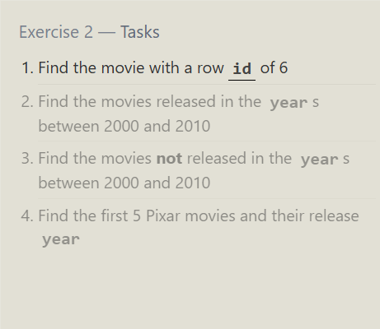

- Find the movie with a row id of 6
SELECT *
FROM Movies
WHERE id = 6;
- Find the movies released in the years between 2000 and 2010
SELECT *
FROM Movies
WHERE year BETWEEN 2000 AND 2010;
- Find the movies not released in the years between 2000 and 2010
SELECT *
FROM Movies
WHERE year NOT BETWEEN 2000 AND 2010;
- Find the first 5 Pixar movies and their release year
SELECT title, year
FROM Movies
LIMIT 5;


- Find all the Toy Story movies
SELECT *
FROM Movies
WHERE title LIKE 'Toy Story%';
- Find all the movies directed by John Lasseter
SELECT *
FROM Movies
WHERE director = 'John Lasseter';
- Find all the movies (and director) not directed by John Lasseter
SELECT title, director
FROM Movies
WHERE director != 'John Lasseter';
- Find all the WALL-* movies
SELECT *
FROM Movies
WHERE title LIKE 'WALL-%';



- List all directors of Pixar movies (alphabetically), without duplicates
SELECT DISTINCT director
FROM Movies
ORDER BY director ASC;
- List the last four Pixar movies released (ordered from most recent to least)
SELECT *
FROM Movies
ORDER BY year DESC
LIMIT 4;
- List the first five Pixar movies sorted alphabetically
SELECT *
FROM Movies
ORDER BY title ASC
LIMIT 5;
- List the next five Pixar movies sorted alphabetically
SELECT *
FROM Movies
ORDER BY title ASC
LIMIT 5 OFFSET 5;
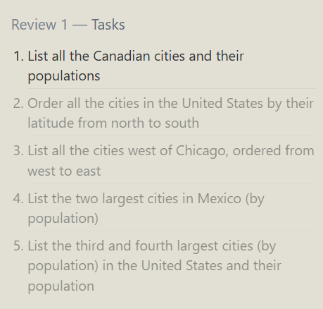
- List all the Canadian cities and their populations
SELECT city, population
FROM North_american_cities
WHERE country = 'Canada';
- Order all the cities in the United States by their latitude from north to south
SELECT *
FROM North_american_cities
WHERE country = 'United States'
ORDER BY latitude DESC;
- List all the cities west of Chicago, ordered from west to east
SELECT *
FROM North_american_cities
WHERE longitude < -87.6298
ORDER BY longitude ASC;

- List the two largest cities in Mexico (by population)
SELECT *
FROM North_american_cities
WHERE country = 'Mexico'
ORDER BY population DESC
LIMIT 2;
- List the third and fourth largest cities (by population) in the United States and their population
SELECT city, population
FROM North_american_cities
WHERE country = 'United States'
ORDER BY population DESC
LIMIT 2 OFFSET 2;

